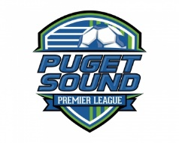Puget Sound Premier League
Player/Parent Concussion and Sudden Cardiac Arrest Awareness Form

The Puget Sound Premier League believes participation in athletics improves physical fitness, coordination, self-discipline, and gives students valuable opportunities to learn important social and life skills.
With this in mind it is important that we do as much as possible to create and maintain an enjoyable and safe environment. As a parent/guardian or player you play a vital role in protecting participants and helping them get the best from sport.
Player and parental education in this area is crucial which is the reason for the Concussion Management and Sudden Cardiac Arrest Awareness pamphlet you received. Refer to it regularly.
This form must be signed annually by the parent/guardian and player prior to participation in the Puget Sound Premier League. If you have questions regarding any of the information provided in the pamphlet, please contact the athletic director at your school.

I HAVE RECEIVED, READ AND UNDERSTAND THE INFORMATION PRESENTED IN THE CONCUSSION RECOGNITION AND SUDDEN CARDIAC ARREST AWARENESS PAMPHLETS.

____________________________________ _______________________________ ________
Student Name (Printed) Student Name (Signed) Date

____________________________________ _______________________________ ________
Parent Name (Printed) Parent Name (Signed) Date

